IBM Data Analyst

Capstone Project

ADITYA YADAV May 2024

# OUTLINE

* Executive Summary
* Introduction
* Methodology
* Results
* Visualization – Charts
* Dashboard
* Discussion
* Findings & Implications
* Conclusion

# EXECUTIVE SUMMARY

* JavaScript, Python, HTML/CSS, SQL, and TypeScript are the most desirable programming languages for next year.
* PostgreSQL, MongoDB, Redis, MySQL, and ElasticSearch are the most desirable databases for next year.
* Gender gap in the IT industry.
* Male = 93.7%
* Female = 6.3%

# INTRODUCTION

* Stack Overflow, a popular website for developers, conducted a survey amongst developers from around the world about technology trends in 2019.
* Programming Languages
* Databases
* Demographics •  Target audience:
* IT professionals
* Anyone interested in the IT field

# METHODOLOGY

* Data Sources:
* Stack Overflow Developers Survey 2019
* Github Job Posting
* Programming Language Annual Salary
* Data Exploration and Cleaning
* Python
* Data Visualization
* IBM Cognos Analytics
* Presentation

# RESULTS

## PROGRAMMING LANGUAGE TRENDS

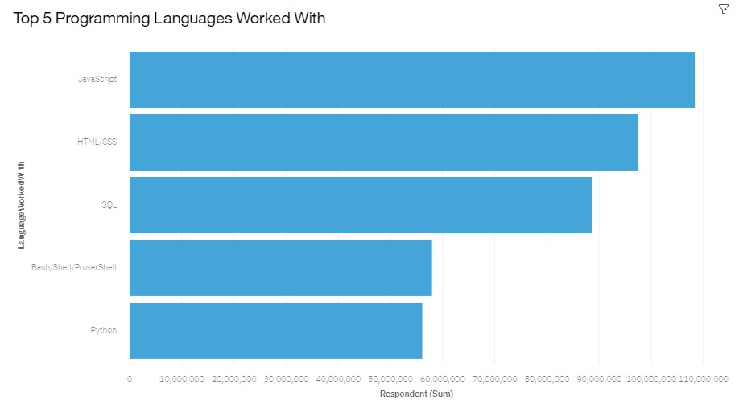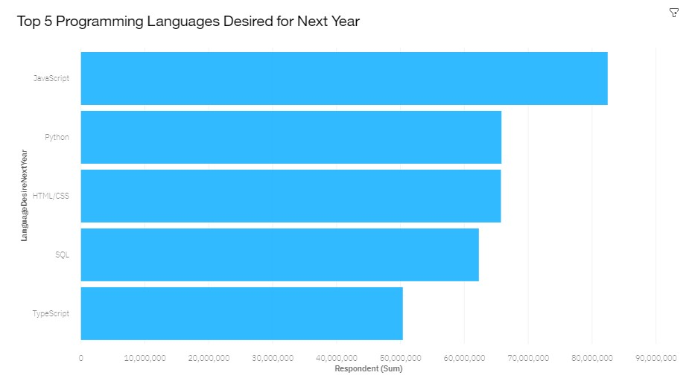

PROGRAMMING LANGUAGE TRENDS – FINDINGS & IMPLICATIONS

### Findings Implications

* JavaScript is the most in demand •  Python’s increase in demand may programming language. overtake JavaScript in the future.
* Python, HTML/CSS, and SQL are •  JavaScript, Python, HTML/CSS, and other in demand programming SQL are consistently in demand.

languages. •  Web development remains in high

* Skills in TypeScript is more desirable demand.

than Bash/Shell/PowerShell for next year.

## DATABASE TRENDS

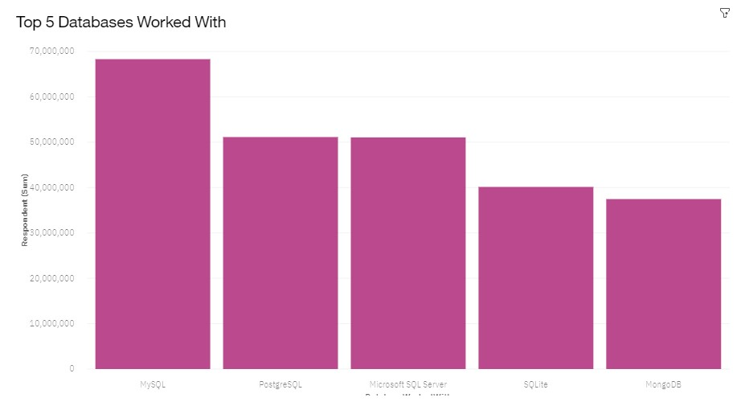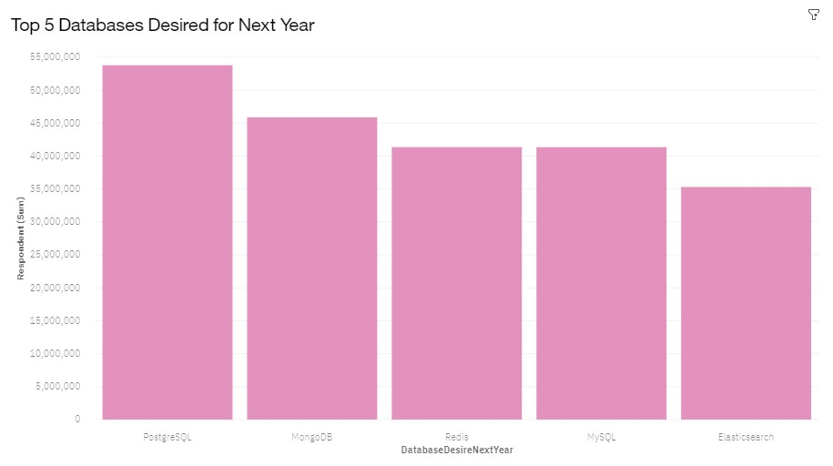

DATABASE TRENDS –

## FINDINGS & IMPLICATIONS

### Findings

* PostgreSQL and MongoDB have an increase in demand.
* MySQL has a decrease in demand for next year.
* Skills in Redis and ElasticSearch are more desirable than Microsoft SQL Server and SQLite for next year.

### Implications

* PostgreSQL and MongoDB are the most consistent in demand databases.
* Open source databases are preferred.
* Demand is volatile.

## GITHUB JOB POSTINGS

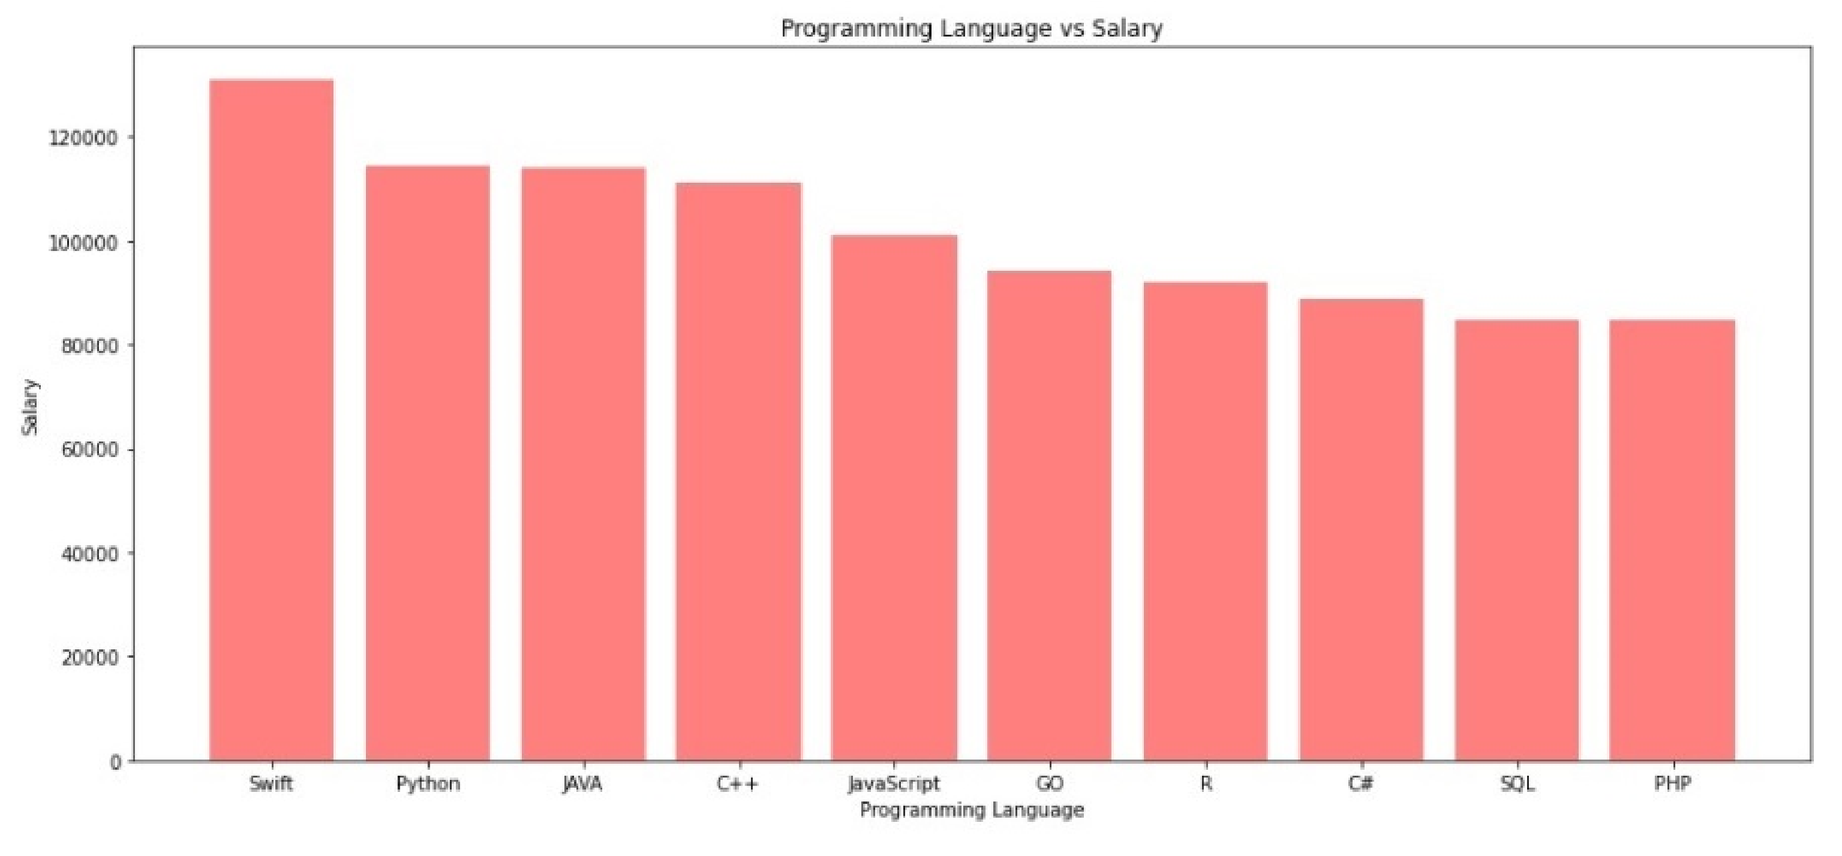

## POPULAR LANGUAGES

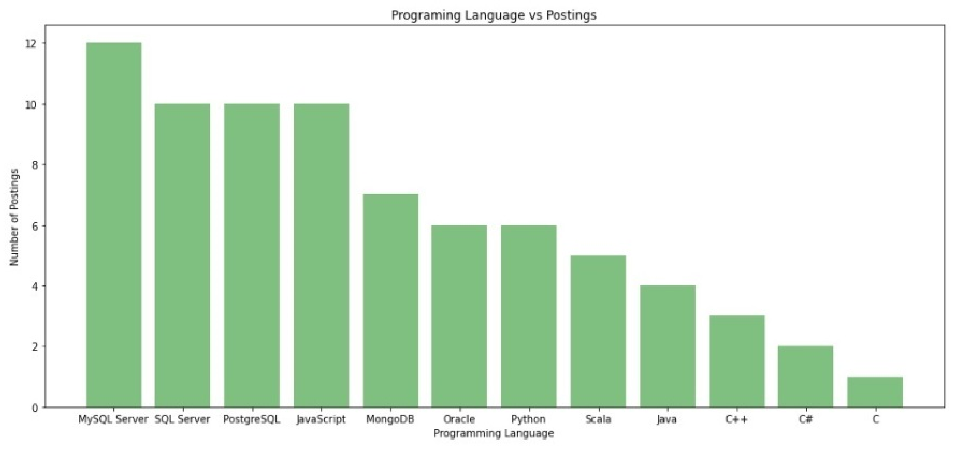

## DASHBOARD

<https://dataplatform.cloud.ibm.com/dashboards/ f0081943-1354-4668-ae48-29245ab2d0f5/view/

5460d50564962be150d0b1e407cf2a527e652c54babb8b0b87d17b

490a602497a83b1196c8284c58da14066bfbe9405ec1>

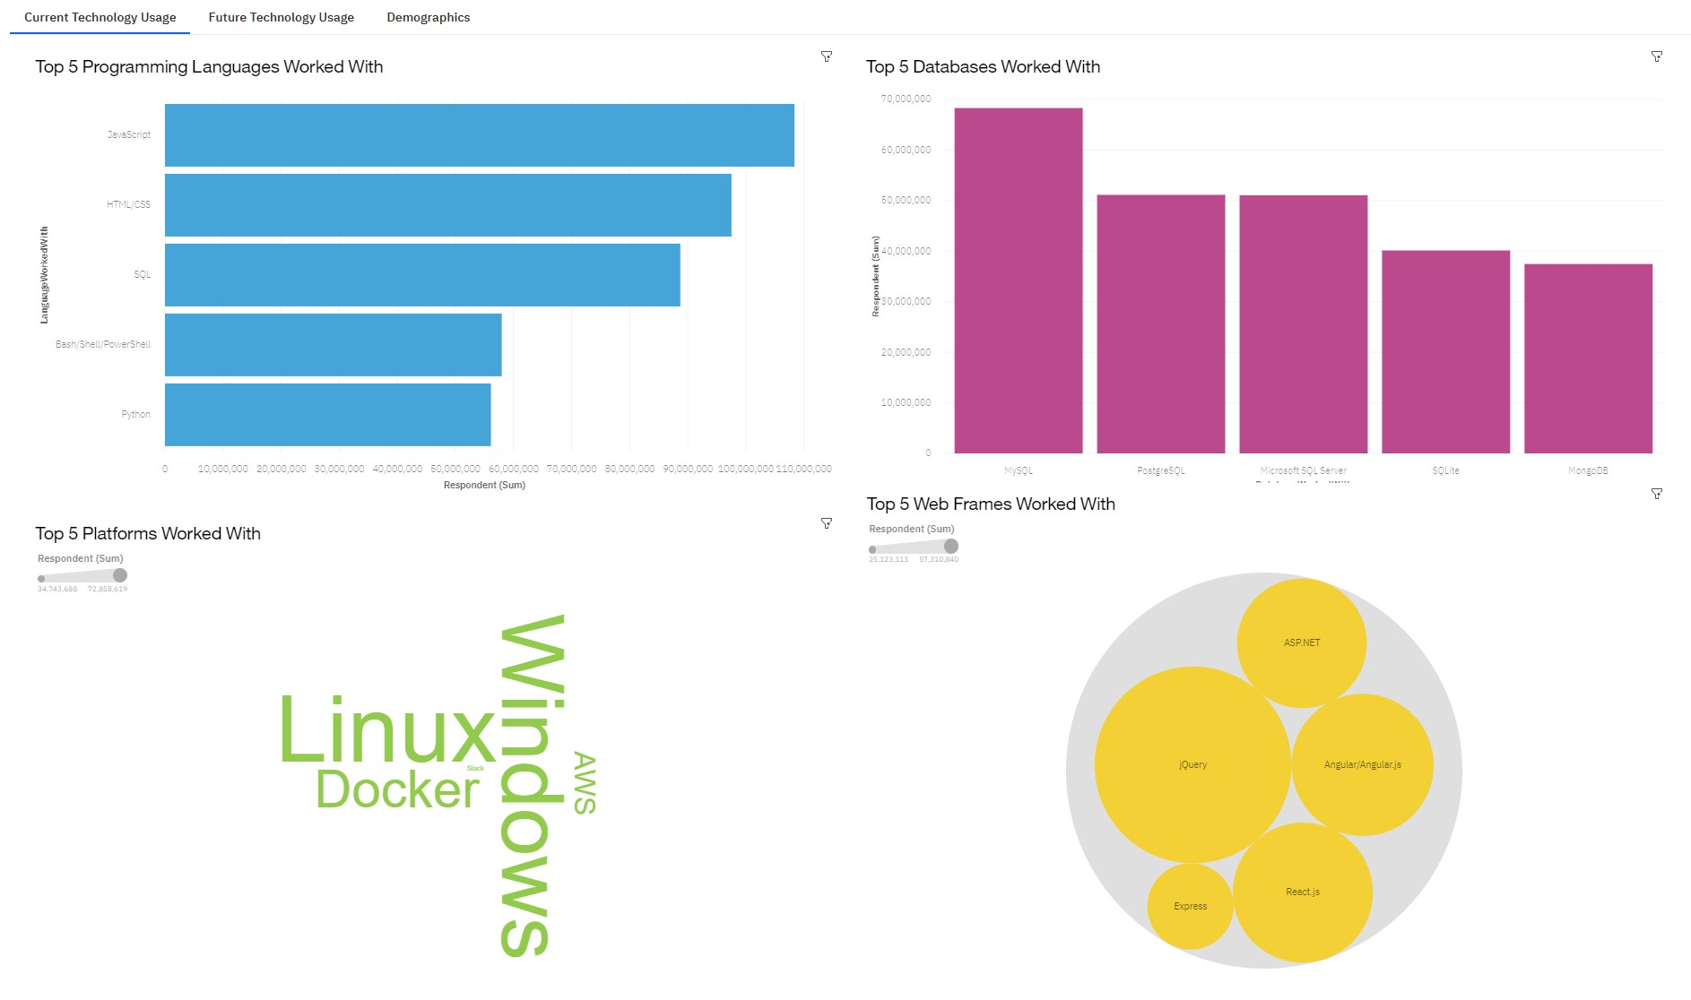

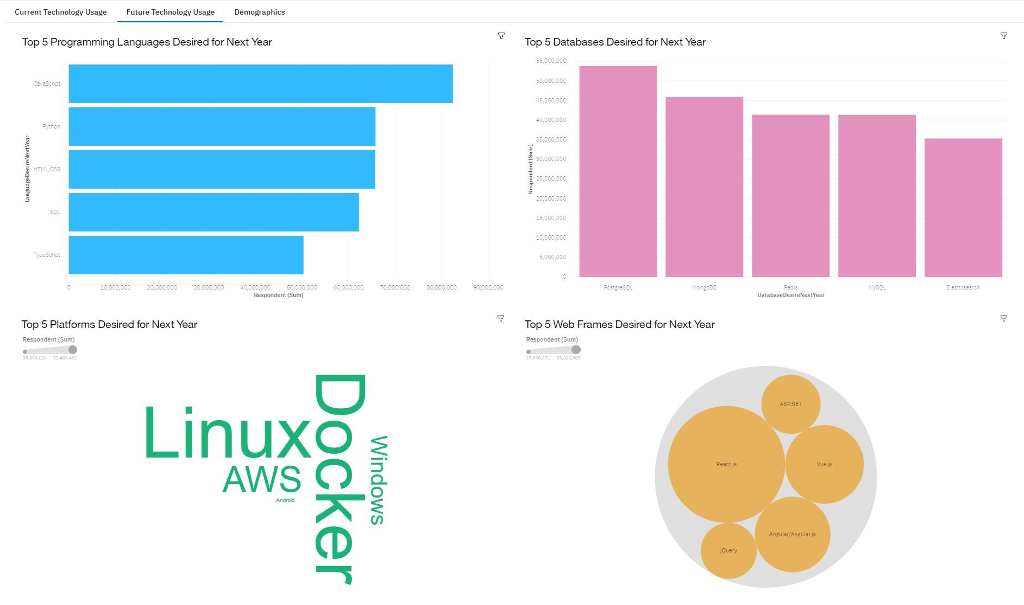

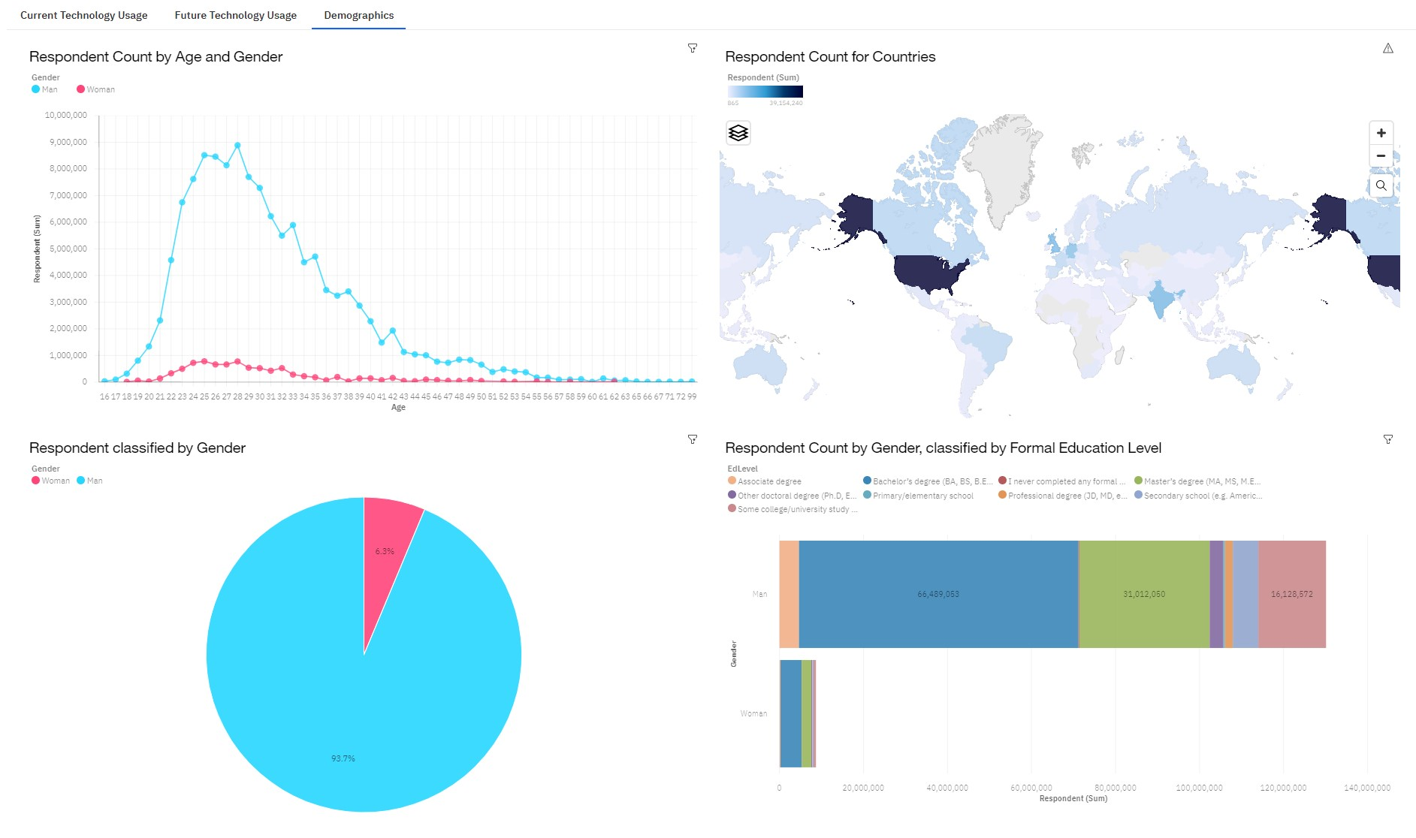

## DISCUSSION

* New technology constantly emerges leading to changes in demand.
* The IT industry needs to diversify in order to eliminate gender gap.

## OVERALL FINDINGS & IMPLICATIONS

### Findings

* Trends and demands fluctuate based on new technologies.
* JavaScript and Python are the most popular programming languages.
* PostgreSQL is the most popular database.
* Gender gap in the IT field.

### Implications

* IT professionals and companies have to learn and adapt to new demands.
* Having skills that are high in demand leads to more job opportunities.
* Gender gap will affect job hiring trend.

## CONCLUSION

* New technology leads to different trends and demands.
* JavaScript and Python are the most popular programming languages.
* PostgreSQL is the most popular database.
* The IT industry needs to diversify.